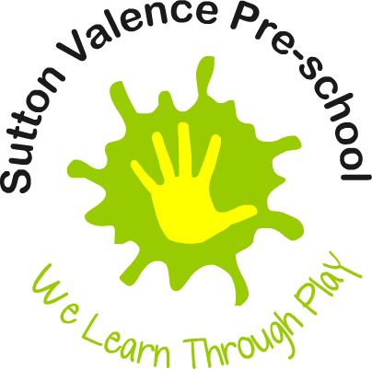 Food and Drink Policy

Statement of intent
This setting regards snack and meal times as an important part of the setting's session/day. Eating represents a social time for children and adults and helps children to learn about healthy eating. The Pre-school Learning Alliance promotes healthy eating.

Aim
At snack times, we aim to provide nutritious food, which meets the children's individual dietary needs. We aim to meet the ‘Statutory Framework’ for the ‘Early Years Foundation Stage’ (EYFS) - Specific legal requirements for Food and Drink.

Methods
- We have a named person who has overall responsibility for our programme for supporting healthy eating, food and drink, including issues concerning health and hygiene. THE HEALTH AND HYGIENE CO-ORDINATOR IS; Fay Davidson
- Before a child starts to attend the setting, we find out from parents/carers their children's dietary needs and preferences, including any allergies.
- We record information about each child's dietary needs in her/his registration record and parents sign the record to signify that it is correct.
- We regularly consult with parents to ensure that our records of their children's dietary needs - including any allergies - are up to date. Parents sign the up-dated record to signify that it is correct.
- We display current information (kitchen area) about individual children's dietary needs so that all staff and volunteers are fully informed about them.
- We implement systems to ensure that children receive only food and drink that is consistent with their dietary needs and preferences as well as their parents' wishes.
- We plan menus in advance and when appropriate involving children and parents in the planning.
- We provide nutritious food at all meals and snacks, avoiding large quantities of saturated fat, sugar and salt and artificial additives, preservatives and colourings.
- We include a variety of healthy foods from the four main food groups: Meat, fish and protein alternatives, Dairy foods, Grains, cereals and starch vegetables and Fruit and vegetables.
- We endeavour to include foods from the diet of each of the children's cultural backgrounds, providing children with familiar foods and introducing them to new ones.
- We take care not to provide food containing nuts or nut products and are especially vigilant where we have a child who has a known allergy to nuts.
- Through discussion with parents and research reading by staff, we obtain information about the dietary rules of the religious groups, to which children and their parents belong, and of vegetarians and vegans, and about food allergies. We take account of this information in the provision of food and drinks.
- We provide a vegetarian alternative on days when meat of fish are offered and make every effort to ensure Halal meat or Kosher food is available for children who require it.
- We require staff to show sensitivity in providing for children's diets and allergies. Staff members do not use a child's diet or allergy as a label for the child or make a child feel singled out because of her/his diet or allergy.
- We organise lunch and snack times so that they are social occasions in which children and staff participate
- We use lunch and snack times to help children to develop independence through making choices, serving food and drink and feeding themselves.
- We provide children with utensils that are appropriate for their ages and stages of development and that take account of the eating practices in their cultures.
- We have fresh drinking water constantly available for the children. We inform the children about how to obtain the water and that they can ask for water at any time during the session/day.
- We inform parents who provide food for their children about the storage facilities available in the setting.
- We give parents who provide food for their children information about suitable containers for food.
- In order to protect children with food allergies, we have rules about children sharing and swapping their food with one another.
- For children who drink milk, we provide whole pasteurised milk.
- Food Hygiene matters are included in staff induction and on the job training.

Packed lunches – Healthy eating.

This setting does not provide cooked meals / hot dinners.
Children are required to bring a healthy packed lunch, we:
- Ensure perishable contents of packed lunches are refrigerated;
- Inform parents of our food and drink policy on healthy eating;
- Encourage parents to provide sandwiches with a healthy filling, fruit, and milk based desserts such as yoghurt or crème fresh.
- We discourage sweet/sugary drinks and can provide children with milk or/and water.
- We discourage packed lunch contents that consist largely of crisps, processed foods, sweet drinks and sweet products such as chocolate, cakes or biscuits.
We (Staff members) reserve the right to return this food to the parent as a last resort
- provide children bringing packed lunches with plates and cups and cutlery; Ensure staff sit with children (where appropriate) to eat their lunch so that the mealtime is a social occasion.
END

This policy was adopted at a meeting of Sutton Valence Pre-School Group;
Annual General Meeting (AGM)

Held on ……………………………………………………………………………………………….
(Full date)

1. Signed ............................................................................................/...................................................
(On behalf of the Management Committee) (E.g. Chairperson)

2. Signed ............................................................................................/...................................................
(On behalf of Staff members) (E.g. Manager)

